Born: 157
Gender: Female
Migration date: mid-summer 226

Position:
Baroness of Lashman – a fortress founded in 103, lost and reclaimed in a civil war of 194, lost to the Flies in 228

Relatives:
Married to Datan Manorbrushes
Mother - Rovod Lawwire: died in 229 during an attack on Bootbegin by the Flies-
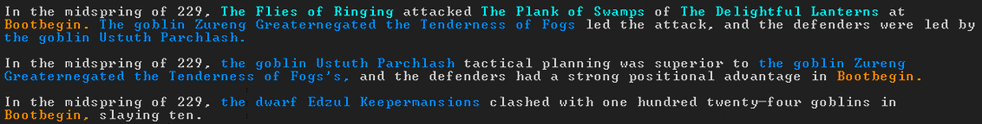
Previous Baroness of Lashman
Father - Risen Wingtrade: alive
Mayor of Boltwire
Has 1 daughter – Kadol Strongrelics, born 227, no details

